Appendix A

Review of Treasury Management 2012/13

Introduction

In February 2012 the Council adopted the 2011 edition of the CIPFA Treasury Management in the Public Services: Code of Practice, which requires the Council to approve a treasury management strategy before the start of each financial year, and provide both a mid-year review, and an annual report after the end of each financial year. This report is the annual report for the 2012/13 financial year.

- Economic Summary 2012/13

During 2012-13 the global outlook stabilised mainly due to central banks maintaining low interest rates and expansionary monetary policy for an extended period. Equity market assets recovered sharply with the FTSE 100 registering a 9.1% increase over the year. This was despite the disappointing economic growth in G-7 nations.
In the UK the economy shrank in the first, second and fourth quarters of calendar 2012. It was the impressive 0.9% growth in the third quarter, aided by the summer Olympic Games, which allowed growth to register 0.2% over the calendar year 2012. The expected boost to net trade from the fall in the value of sterling did not materialise, but raised the price of imports, especially low margin goods such as food and energy. Avoiding a ‘triple-dip’ recession became contingent on upbeat services sector surveys translating into sufficient economic activity to overhaul contractions in the struggling manufacturing and construction sectors.

Household financial conditions and purchasing power were constrained as wage growth remained subdued at 1.2% and was outstripped by inflation. Annual CPI dipped below 3%, falling to 2.4% in June before ticking up to 2.8% in February 2013. Higher food and energy prices and higher transport costs were some of the principal contributors to inflation remaining above the Bank of England’s 2% CPI target.

The lack of growth and the fall in inflation were persuasive enough for the Bank of England to maintain the Bank Rate at 0.5% and also sanction additional £50 billion asset purchases (QE) in July, taking total QE to £375 billion. The possibility of a rate cut was discussed at some of the Bank’s Monetary Policy Committee meetings, but never implemented.

In March the Office for Budgetary Responsibility (OBR) halved its forecast growth in 2013 to 0.6% which then resulted in the lowering of the forecast for tax revenues and an increase in the budget deficit. The government is now expected to borrow an additional £146bn and sees gross debt rising above 100% of GDP by 2015-16. The fall in debt as a percentage of GDP, which the coalition had targeted for 2015-16, was pushed two years beyond this horizon. With the national debt metrics out of kilter with a triple-A rating, the UK’s sovereign rating was downgraded by Moody’s to Aa1. The AAA status was maintained by Fitch and S&P, albeit with a Rating Watch Negative and with a Negative Outlook respectively.

The government’s Funding for Lending (FLS) initiative commenced in August which gave banks access to cheaper funding on the basis that it would then result in them passing this advantage to the wider economy. There was an improvement in the flow of credit to mortgagees, but was still below expectation for businesses.

Growth was hindered by the rebalancing processes under way in Euroland economies, most of which contracted in Q4 2012, and in the US the Federal Reserve shifted policy to focus on the jobless rate with a pledge to keep rates low until unemployment falls below 6.5%. The country’s extended fiscal and debt ceiling negotiations remained unresolved, although negotiations in December did provide some respite.

Gilt yields ended the year lower than the start in April. By September the 2-year gilt yield had fallen to 0.06%, raising the prospect that short-dated yields could turn negative. 10-year yields fell by nearly 0.5% ending the year at 1.72%. The reduction was less pronounced at the longer end; 30-year yields ended the year at 3.11%, around 25bp lower than in April. Despite the likelihood the DMO would revise up its gilt issuance for 2012/13, there were several gilt-supportive factors: the Bank of England’s continued purchases of gilts under an extended QE programme; purchases by banks, insurance companies and pension funds driven by capital requirements and the preference for safe harbour government bonds.

One direct consequence of the Funding for Lending Scheme was the sharp drop in rates at which banks borrowed from local government. 3-month, 6-month and 12-month Libid rates which were 1%, 1.33% and 1.84% at the beginning of the financial year fell to 0.44%, 0.51% and 0.75% respectively.

- Treasury Management Strategy 2012/13

The Full Council approved the 2012/13 treasury management strategy at its meeting on 23rd February 2012. The Council’s stated investment priorities were:

(a) security of capital and
(b) liquidity of its investments.

The Council also aimed to achieve the optimum return on its investments commensurate with proper levels of security and liquidity. The risk appetite of the Council is low in order to give priority to security of its investments.

The Council’s stated borrowing strategy was to take advantage of historically low short term interest rates by borrowing short term in the money markets rather than financing capital expenditure through long term PWLB loans.

The County Treasurer can report that all treasury management activity undertaken during the financial year complied with the CIPFA Code of Practice and the relevant legislative provisions.

- Treasury Management Activities in 2012/13

Borrowing Activity 2012/13

The revised 2012/13 borrowing requirement was estimated at £320.631m after taking into account the updated capital programme and the refinancing of existing borrowing, including short term borrowing taken to meet the Capital Financing Requirement. The table below shows the 2012/13 revised borrowing requirement as agreed within the 2013/14 treasury management strategy report, along with the actual position as at 31st March 2013.

 | 2012/13 Revised | 2012/13  Actual | 2013/14 Estimate
 | £m | £m | £m
Capital Programme Expenditure | 143.814 | 139.403 | 165.808
Financed by:  Capital Receipts | 0 | 0 | 9.274
Grants and Contributions | 114.293 | 111.270 | 125.598
Revenue Contributions | 29.521 | 28.133 | 29.521
Borrowing | 0 | 0 | 1.415
Add Maturing Debt to be replaced:
Long Term PWLB | 0 | 0 | 0
Short Term Market Borrowing | 351.317 | 351.317 | 351.317
Less Transferred Debt | 2.121 | 2.121 | 2.033
Less Statutory Charge to Revenue | 28.565 | 28.865 | 26.573
Total Borrowing Requirement | 320.631 | 320.33 | 324.126

As estimated in the revised capital programme no new borrowing was required to finance the capital programme.

Analysis of Debt Outstanding

The following table sets out the structure of the County Council’s debt at 31st March 2013.

 | Debt at  31 March 2012 |  | Borrowing | Repayments |  | Debt at  31 March 2013
 | £m | % | £m | £m | £m |  | %

Fixed Rate Funding
Public Works Loan Board | 213.100 | 26.04 |  |  | 213.100 |  | 26.04
LOBO (RBS) | 50.000 | 6.31 |  |  | 50.000 |  | 6.31
Local Bonds | 0.022 | 0.00 |  |  | 0.022 |  | 0.00
Short term Market Borrowing | 304.600 | 37.22 | 505.870 | 523.220 | 287.250 |  | 37.22
 | 567.722 |  | 505.870 | 523.220 | 550.372

Variable Rate Funding
Public Works Loan Board | 185.750 | 22.70 | 0 | 60.000 | 125.750 |  | 22.70
Shared Investment Scheme | 63.254 | 7.73 | 537.059 | 538.820 | 61.493 |  | 7.73
 | 249.004 |  | 537.059 | 598.820 | 187.243
Loan Debt Administered by the County Council | 816.726 | 100.0 | 1,042.929 | 1,122.040 | 737.615 |  | 100

The total loan debt administered by the County Council at 31 March 2013 of £737.615m represents mainly borrowings over the years to finance the acquisition of the County Council’s fixed assets, which are currently valued at £2.657 billion. However, it includes £43.106m managed by the County Council on behalf of other local authorities and the Lancashire Police and Crime Commissioner. This debt relates to assets transferred to those authorities in local government re-organisations and the financing charges are repaid to the County Council quarterly. This leaves the net debt for which the County Council is responsible at £694.509m.

The economic background has continued to be characterised by very low short term interest rates, and market borrowing rates consistently lower than those offered by the Public Works Loan Board (PWLB). Consequently the County Council has continued a rolling programme of short term market borrowing to finance the current capital financing requirement as an alternative strategy of financing through long term PWLB loans

Overall the average rate of interest paid in 2012/13 on the debt administered by the County Council was 2.45% per annum compared with an average rate of 2.11% in 2011/12, 2.69% in 2010/11 and 4.37% in 2009/10.

The current strategy of taking advantage of very low short term interest rates, whilst extremely cost effective, means that much more of the Council's debt needs to be refinanced in the short term, so exposing the portfolio to some interest rate and liquidity risk which will be carefully monitored during the coming year.

The chart below shows the maturity profile of the County Council's debt.

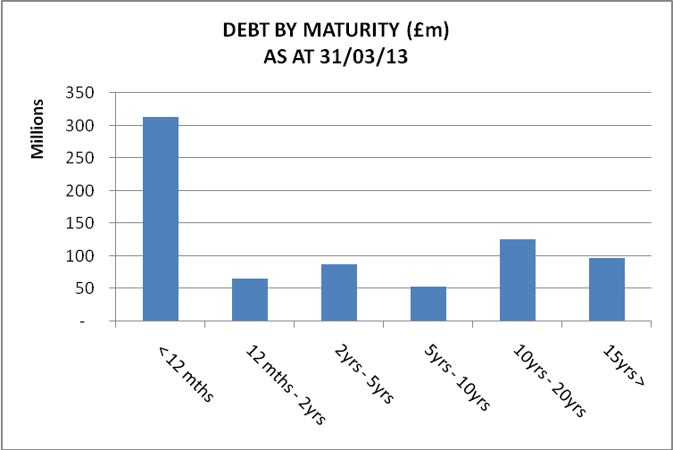

There is a significant level of short term borrowing which needs to be constantly refinanced as part of the strategy to benefit from low short term rates. This gives rise to some interest rate risk, although this is mitigated by the ability of the Council to switch from short term to long term borrowing should the UK enter as period of rising interest rates, as the expectation is that rates would rise in a series of steps over a protracted period rather than in a single event.

As part of a balanced portfolio, the risk is further mitigated by two factors:

- Maturing and available for sale short term investments, which could, if necessary, be used to pay down debt, should it become cost effective to do so.
- It is also mitigated by a long term £50m loan taken on a Lender Option Borrower Option (LOBO) basis. The interest rate of this loan is 7.52% less the sterling 10 year swap rate, providing an inverse relationship with interest rates - the interest payable on the loan will fall as interest rates rise.

The County Treasurer will continue to closely monitor interest rate forecasts in order to establish when long term interest rates might be expected to rise. At some point, it will be beneficial to the County Council for the short term borrowing to be fixed for a longer period before long term rates rise, but current forecasts do not anticipate a rate rise in the near future.

Investment of Cash Balances

With continued economic uncertainty and volatility in financial markets the County Council still retains the majority of the Council's investments in UK Government guaranteed bonds or deposits in institutions with Government ownership/support.

Like most other councils, Lancashire has a benchmark for the average rate of interest earned on its invested cash balances. The benchmark rate is the average commercial market rate for money deposited on 7 days’ notice. During 2012/13, on average, that rate was 0.39%, with Lancashire’s average rate being 4.25% over the same period, reflecting the longer term deals which are still attracting a relatively high interest rate.

The total amount of investments held by Lancashire County Council at 31st March 2013 is £576.7m including £49.542m of cash and cash equivalents. The table below shows the asset classes and the proportion of investments held in each class.

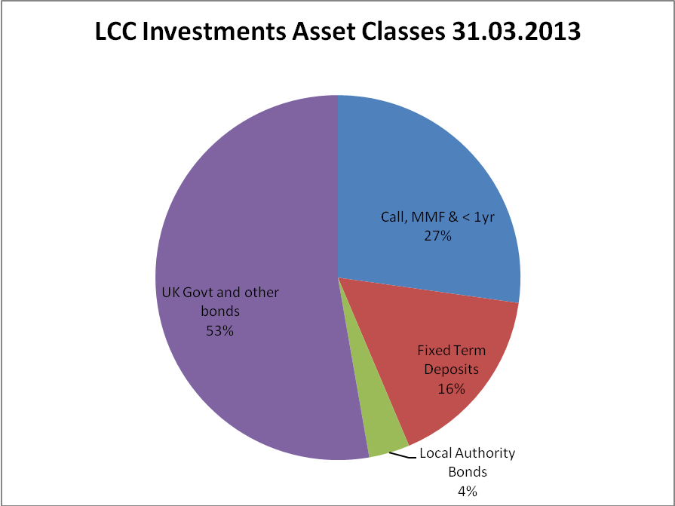
The table below shows a maturity analysis of the portfolio at 31st March 2013, alongside the average interest rate earned over the 2012/13 financial year.

Maturity Range | Amount £m | Average Rate %
Call, Money Market Funds & Under 1yr | 154.14 | 2.27
Bank Deposit 1-2 Years | 20.00 | 2.62
Bank Deposit 2-3 Years | 72.92 | 2.96
Bank Deposit 3-5 Years | 0 | 0
Bank Deposit 5 Years + | 0 | 0
Local Authority Bonds | 20.50 | 7.61
UK Government and Supranational Bonds | 298.67 | 6.04
Total | 566.23 | 4.25

4. Financing Charges Summary at the end of the 2012/13 Financial Year

The 2012/13 financing charges budget was set at £35.004m, against which the end of year position was £21.345m representing an underspend of £13.659m. Further detail is set out in the table below:

Financing Charges 2012/13 – End of Year Position

 | Budget | Year End Position | Variance
 | £m | £m | £m
Statutory Charge to Revenue  Additional Charge to Revenue (Internal Leasing) | 28.496 | 28.865  2.762 | 3.131
Interest paid | 18.220 | 18.234 | 0.014
Investment interest received | -11.712 | -28.516 | -16.804
Total net financing charges | 35.004 | 21.345 | -13.659

Expenditure against the financing charges budget is lower than anticipated because of higher interest earned on investments due to longer term nature of structured deposits with UK Government owned banks and above benchmark returns on the bond portfolio. This is partially offset by additional MRP contributions to reflect the increase in the asset base in 2012-13 and an increased contribution to the vehicle replacement reserve.

The position above is calculated in accordance with International Financial Reporting Standards and reflects a prudent view of the valuation of financial instruments by recognising the impact of any unrealised losses arising from movements in the valuation of financial instruments held for trading in the revenue account regardless of whether or not the intention is to sell them.

- Treasury Management Prudential Indicators 2012/2013

The Local Government Act 2003 and supporting regulations require the County Council to have regard to the prudential code and to set prudential indicators to ensure the County Council's capital investment plans are affordable, prudent and sustainable.

A comparison of the actual position at 31 March 2013 compared to the prudential indicators set in the treasury management strategy for 2012/13 is set out below.

Treasury Management Prudential Indicators | 2012/13 | 2012/13  Actual
 | £m | £m
- Adoption of CIPFA TM Code of Practice  - Authorised limit for external debt - A prudent estimate of debt, which reflects the Authority’s capital expenditure plans and allows sufficient headroom for unusual cash movements. | aDoPtEd
Borrowing | 887 | 740
Other long-term liabilities(PFI schemes) | 500 | 411
TOTAL | 1,387 | 1151
- Operational boundary for external debt - A prudent estimate of debt, but no provision for unusual cash movements. It represents the estimated maximum external debt arising as a consequence of the County Council's current plans.
Borrowing | 837 | 740
Other long-term liabilities | 450 | 411
TOTAL | 1,287 | 1,151
- Upper limit for fixed rate debt | 220 | 9
- Upper limit for variable rate debt | 220 | 195
- Upper Limit for Bank Deposits over 364 days  This limit does not apply to UK or AAA rated foreign Government or Supra National Bank securities. | 75% | 37%
- Maturity structure of debt
 | Lower Limit % | Upper Limit % | Actual %
Under 12 months |  | 75 | 42.2
12 months and within 2 years |  | 75 | 8.8
2 years and within 5 years |  | 75 | 11.8
5 years and within 10 years |  | 75 | 7.2
10 years and above | 25 | 100 | 30.0

- Investment in Landsbanki Is.

Lancashire County Council had £6.436m on deposit with the Icelandic Bank Landsbanki Is. when it collapsed in October 2008. The Authority was one of many UK and Dutch Local Authorities with such deposits, all of whom were granted priority creditor status by the Icelandic Supreme Court at a hearing in Reykjavik on 14th and 15th of September 2011. As a consequence the Winding Up Board announced on 9 March 2012 that it anticipated recoveries in the Landsbanki Administration would exceed the book value of recognised priority claims by around ISK 121bn, taking into account the sale of its holding in Iceland Foods. Estimated recoveries are some 9% higher than the value of priority claims, and it is therefore now considered likely that UK local authorities will recover 100% of their deposits, subject to potential future exchange rate fluctuations.

The winding up board made its first distribution on 7th December 2011, being approximately 29% of the total. Subsequent distributions were made on 25th May 2012 and 9th October 2012 so that by 31st March 2013 47% of the claim had been recovered.

The total amount of the claim is £6.529m, made up of principal of £6.436m and interest of £0.093m. From the three distributions made to date the County Council has received a total of £3.097m, of which £3.054m is principal and £0.043m is interest.

The timing of future payments is uncertain, and the Landsbanki Winding Up Board have not, at present, indicated when the next distribution will be made.

